- Purpose
  - The purpose of this document is to describe the procedure for calibrating the TDS Board and sensors for all GeneSys machines with SoliChem.
- Scope
  - This SOP applies to all equipment assembly team members. The process applies to all GeneSys machines with the SoliChem option
- Responsibilities
  - The QC manager/supervisor is responsible for enforcing this SOP.
- Materials
  - The proper materials needed for this process are listed on the machine work order.
- Definitions

- Procedure
  - Start with a new clean and soapy water sample jar.
  - Check the water and soap solution “parts per million” using the gauge provided. Water should be 100-200 and soap should be 600-800. We want to log the findings at the beginning of all TDS calibrations. (Log location: H:\Manufacturing\Equipment\Quality Control – Equipment)

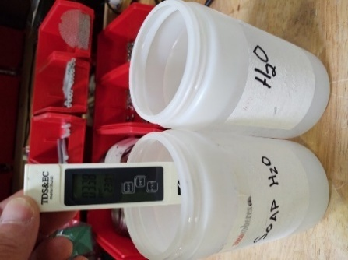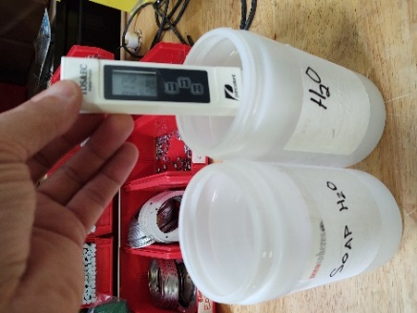

  - Gather a TDS board (E28784), possibly mounted in box, and 2 TDS probe assemblies (SOP EQ 101). Also, set up a 24V power supply with the harness that has the 4-pin connector and the LED. Ensure the power supply is set to 24V then turn the power of the unit back off.
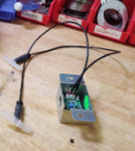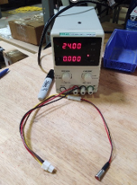
  - Connect the 4-pin connector from the harness to the appropriate spot on the board. Connect two probes to the appropriate positions on the board.

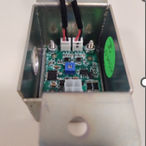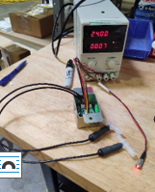

  - Put both probes into the jar of clean water and swish them around so that there are no air bubbles trapped in them.

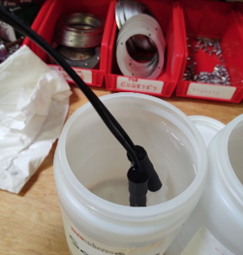

  - Turn the power supply on and remove the jumper from the TDS board.

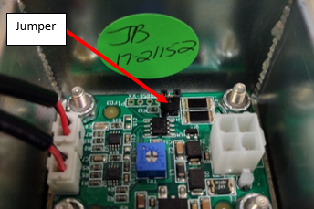
  - The LED light should blink. Let it blink for 20-30 seconds.
  - Put the jumper back on and then quickly remove it again. Try to do this within 1 second.
  - The LED should go out. Once it does, turn the power supply off for 3 seconds.
  - After the 3 seconds, turn the power supply back on. The light should turn on.
  - The light should now turn off within approximately 30 seconds. If it does not turn off after 40 seconds, put the jumper on and repeat steps 6.05 through 6.11.
  - If the light correctly turns off, take one of the probes and place it into the jar of soapy water. Swish it around to get any air bubbles out.

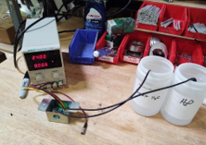

  - The light should turn on after 30-40 seconds. If it does not, you need to go back to the beginning of the calibration process and start over.
  - When the light turns on, place the probes back into the clean water. The light should go out after approximately 30 seconds.
  - Repeat the clean to soapy water swap a couple times to ensure that the light turns on and off appropriately.
  - Calibration is complete.

- References (optional section as needed)

- Training Guide

Functional Training Groups Requiring Training
Equipment Assembly Group

- SOP Change Control

Date of Change | Reason for Change
Rev 01 - 7/21/2021 | Changed procedure for correct calibration process.
Rev 02 – 11/20/2025 | Revised procedure

Approvals

Submitter/Author Approval:__________________________________ Date:______________________

Management Approval:______________________________________ Date:______________________

QAU Approval: _____________________________________________ Date:______________________

